**Introduction to Computer Hardware**

Computer hardware refers to the tangible, physical components that form the foundation of any computer system. These components work together to process, store, and communicate data, enabling the smooth operation of both hardware and software.

**Motherboard**

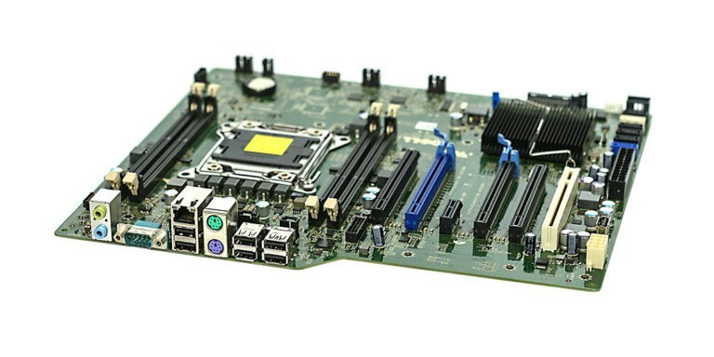

The motherboard is the main circuit board of a computer, acting as a central platform that connects all other hardware components. It facilitates communication between the CPU, RAM, storage devices, and peripherals. Key features include:

* **CPU Socket**: Slot for installing the central processing unit.
* **RAM Slots**: Connectors for memory modules.
* **Expansion Slots**: Such as PCIe slots for adding graphics cards, sound cards, or network cards.
* **Chipset**: Manages data flow between the processor, memory, and other components.
* **Power Connectors**: Distributes power to the components via the SMPS.
* **Input/Output Ports**: Includes USB, HDMI, Ethernet, and audio ports for connecting external devices.

Motherboards come in various sizes (e.g., ATX, Micro-ATX) and are tailored to support specific CPUs and features. It is often referred to as the "backbone" of a computer due to its critical role in ensuring seamless hardware functionality.

**RAM (Random Access Memory) Modules**

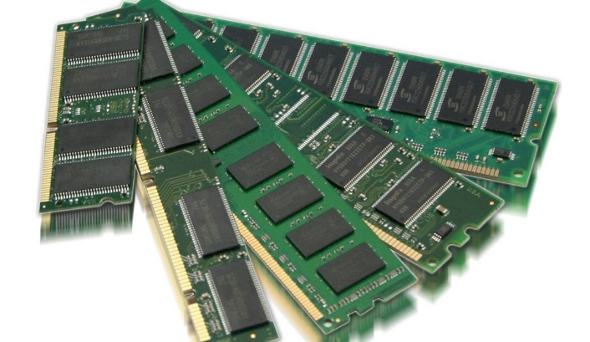

RAM is a type of volatile memory that temporarily stores data and instructions that the CPU needs while a computer is running. It plays a vital role in system performance by providing fast, temporary storage for active processes and applications.

**Features:**

* **Volatile Memory**: Data is lost when the power is turned off.
* **Speed**: Much faster than traditional storage devices like HDDs or SSDs.
* **Capacity**: Typically ranges from 4GB to 64GB or more, depending on the use case.
* **Types**: DDR3, DDR4, and DDR5 are common generations, with DDR5 being the latest and fastest.
* **Form Factors**: Comes in DIMMs (for desktops) or SO-DIMMs (for laptops).

Having sufficient RAM ensures smooth multitasking and faster application performance, making it a critical component for any computer system.

**Daughter Cards**

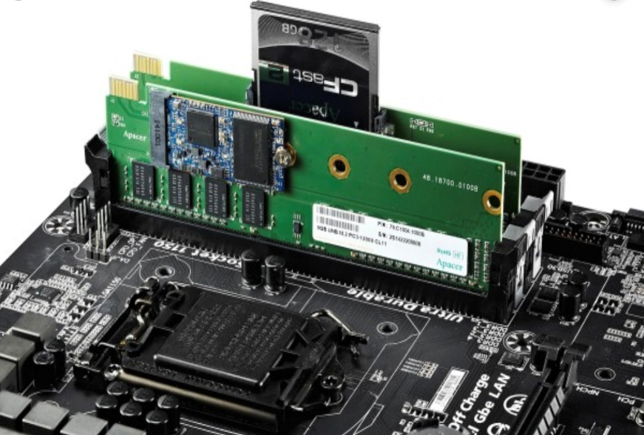

Daughter cards, also known as expansion cards or add-on cards, are small circuit boards that can be plugged into a motherboard to enhance or expand a computer's functionality. These cards connect via bus slots like PCI, PCIe, or AGP on the motherboard.

**Common Types of Daughter Cards:**

1. **Graphics Card (GPU)**: Enhances the computer's ability to process and display graphics, used in gaming, video editing, and 3D modeling.
2. **Sound Card**: Improves audio quality for applications like music production or gaming.
3. **Network Interface Card (NIC)**: Provides or upgrades a system’s networking capabilities, including wired and wireless connections.
4. **TV Tuner Card**: Allows the computer to receive and decode television signals.
5. **Capture Card**: Used for capturing video input from cameras or other devices for streaming or recording.

**Features:**

* Plug-and-play capability for ease of use.
* Designed to meet specific performance needs, such as high-quality visuals or faster networking.
* Available in various sizes and specifications to suit different systems.

Daughter cards allow for the customization and scalability of a computer system, making them an essential component for specialized tasks.

**Bus Slots**

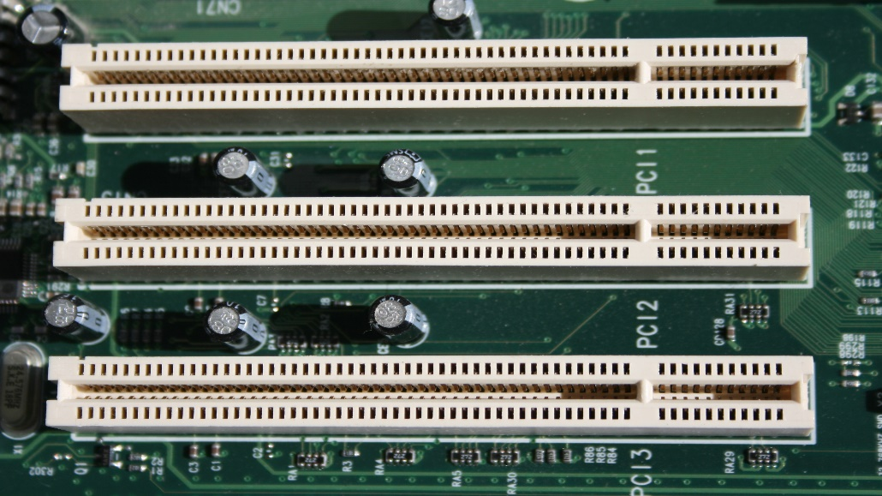

Bus slots are connectors on a computer's motherboard that allow expansion cards (daughter cards) to be installed, enabling additional functionalities like improved graphics, sound, or networking. They serve as pathways for data transfer between the motherboard and connected devices.

**Common Types of Bus Slots:**

1. **PCI (Peripheral Component Interconnect)**: An older standard used for various expansion cards.
2. **PCIe (PCI Express)**: A faster, more modern version for high-speed devices like graphics cards and SSDs.
3. **AGP (Accelerated Graphics Port)**: Specifically designed for older graphics cards (now largely obsolete).
4. **ISA (Industry Standard Architecture)**: Used in very early computers for basic expansion needs (no longer in use).

**Features:**

* Different slots support different speeds and capabilities.
* Crucial for upgrading and customizing a computer's performance.

Bus slots allow systems to adapt to changing needs by adding or upgrading components, making them essential for modularity and scalability.

**SMPS (Switched Mode Power Supply)**

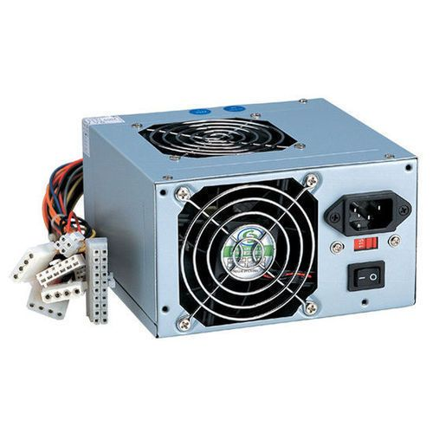

SMPS is a hardware component that provides power to a computer by converting electrical energy from the mains into the low-voltage DC power required by internal components. It is designed to be efficient and compact.

**Features:**

1. **Voltage Conversion**: Converts high-voltage AC (Alternating Current) into low-voltage DC (Direct Current) power.
2. **Efficiency**: Uses high-frequency switching for minimal energy loss.
3. **Multiple Outputs**: Supplies different voltages (e.g., 3.3V, 5V, 12V) to power various components like the CPU, motherboard, and storage devices.
4. **Protection**: Includes safeguards against over-voltage, over-current, and short circuits.

**Importance:**

SMPS ensures stable and reliable power delivery, protecting components and enabling smooth operation of the computer system.

**Internal Storage Devices**

Internal storage devices are components within a computer that store data, including the operating system, applications, and user files. They are crucial for data storage and retrieval.

**Types of Internal Storage Devices:**

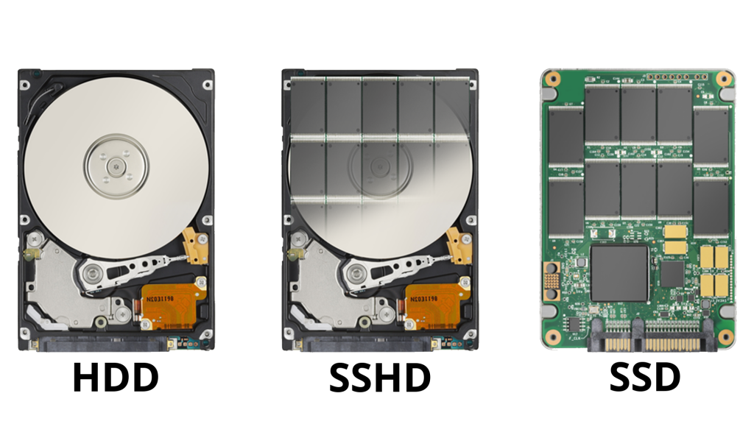

1. **HDD (Hard Disk Drive)**:
   * Uses spinning magnetic disks to store data.
   * Offers large storage capacity (e.g., 1TB, 2TB) at a lower cost.
   * Slower read/write speeds compared to SSDs.
2. **SSD (Solid State Drive)**:
   * Uses flash memory with no moving parts.
   * Provides faster performance, reliability, and durability.
   * Common capacities range from 256GB to 2TB.
3. **Hybrid Drives (SSHD)**:
   * Combines features of HDDs and SSDs, with a small SSD cache for faster access to frequently used data.

**Interfacing Ports**

Interfacing ports are connection points on a computer that allow it to communicate with external devices. These ports facilitate data transfer, input, output, and power supply.

**Common Types of Interfacing Ports:**

1. **USB (Universal Serial Bus)**:

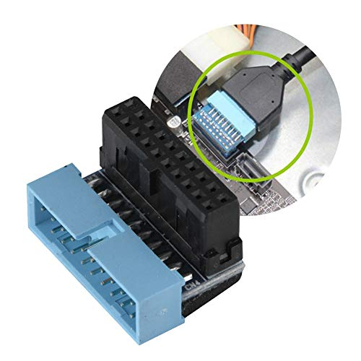

* + Widely used for peripherals like keyboards, mice, and external drives.
  + Versions include USB 2.0, 3.0, and 3.1, offering different speeds.

1. **HDMI (High-Definition Multimedia Interface)**:

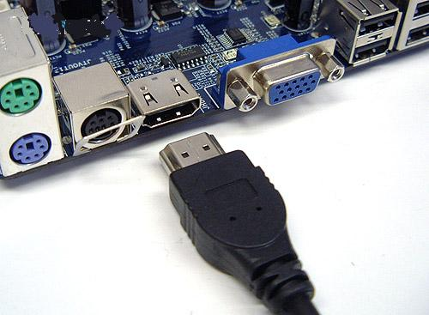

* + Transmits high-quality audio and video to monitors, TVs, or projectors.

1. **Ethernet Port**:

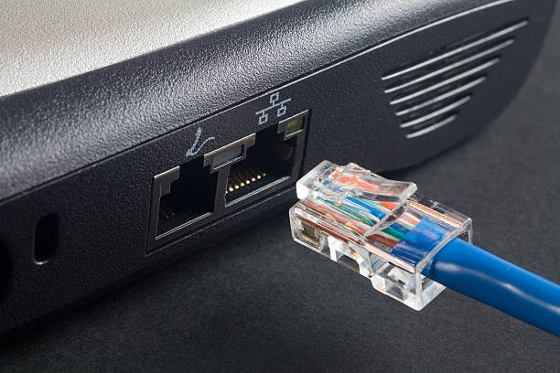

* + Used for wired network connections, offering stable and fast internet access.

1. **Audio Ports**:

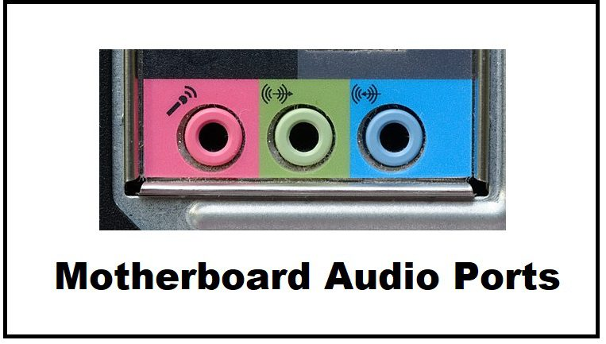

* + Includes headphone jacks and microphone inputs for audio devices.

1. **VGA/DVI Ports**:

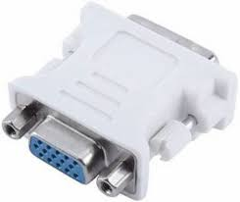

* + Older ports for connecting monitors to display video output.

1. **Thunderbolt/USB-C**:

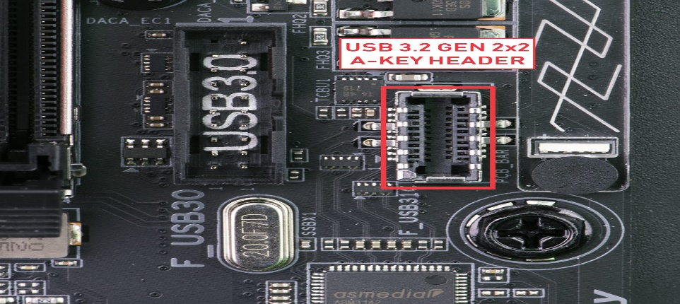

* + High-speed ports for data transfer, charging, and video output.

**Importance:**

Interfacing ports are essential for connecting a computer to external devices, enabling efficient communication and functionality in modern systems.

**Desktop vs. Server-Class Computer Specifications**

1. **Desktop Computers**:
   * Designed for personal use or small-scale office work.
   * Typical specifications:
     + **CPU**: Dual or quad-core processors (e.g., Intel Core i5, AMD Ryzen 5).
     + **RAM**: 8GB to 16GB.
     + **Storage**: SSD (512GB) or HDD (1TB).
     + **Graphics**: Integrated or entry-level GPU.
2. **Server-Class Computers**:
   * Built for high-demand operations, including data hosting and application management.
   * Typical specifications:
     + **CPU**: Multi-core processors like Intel Xeon or AMD EPYC.
     + **RAM**: 32GB to terabytes, depending on workload.
     + **Storage**: High-capacity RAID-configured HDDs/SSDs.
     + **Networking**: Redundant NICs for high-speed, fail-safe connectivity.